NVHS Volunteer Application 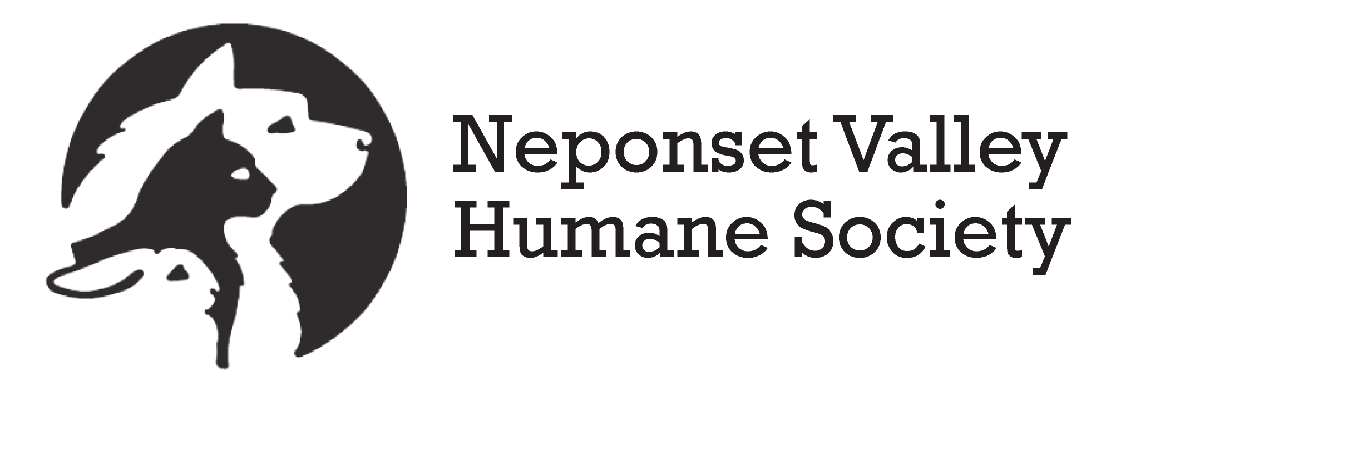

Thank you for your interest in volunteering with Neponset Valley Humane Society. NVHS was founded in 1993. We are a 501(c)(3) non-profit charitable organization supported entirely by private donations. We are all volunteers and can always use more help!!!

Name: Are you 18 or older*? YES NO

Address:

Home phone: Cell Phone: Work phone:
Please note the best number to reach you.

E-mail address:

How did you hear about NVHS?

These are examples of several Volunteer Opportunities available with NVHS. Some may change and/or be busier during specific times of year/as the needs change.

Foster Care. We do not have a shelter, so we rely solely on our foster homes. Fostering is very rewarding, fun and a great opportunity for the whole family. NVHS will assign rescued cats or kittens that need to live in a family environment while waiting to be adopted. NVHS provides veterinary care, while you provide the Love. If needed, NVHS can also provide the food, litter and supplies. Foster families are a critical part of our ability to rescue cats in need.

Cat Rescue Team Volunteer. This volunteer opportunity is for experienced cat handlers. Our volunteer Cat Rescue Team members work in the field to rescue and evaluate cats in need. These might be feral cats, who need to be TNR’d (Trap/Neuter/Release) or they might be friendly, abandoned pets who need to go into our adoption and foster care system. We have competent, compassionate rescue volunteers willing to train. This volunteer position involves handling cats with unknown histories, temperaments and health. It is all about helping cats who need help.

Senior Cat Care Team Members. NVHS has a wonderful Senior-for-Senior Program that matches local Senior Citizens with senior cats in need of homes. We have a variety of volunteer opportunities needed for this program including nail clipping, food/supplies delivery, transport for medical appointments and well-being check in visits if necessary.

Sponsor a Cat Program. If time is an issue, then you can always help out by financially sponsoring a cat in need. NVHS provides food, supplies and medical needs for our foster cats and Senior Program. Some cats, in particular those we rescue who have been abandoned or abused, need medical attention and special care. Your generous donations will help a very special cat in need of more than just our love and attention. You can choose a cat to Sponsor or make a donation that will help any of our beloved cats.

Fundraising Coordinator. If you enjoy event planning and/or have experience with fundraising, we need you! NVHS holds several fundraising events throughout the year. We need someone who can bring fresh and effective ideas, coordinate activities and assist with other logistics to ensure a successful event. Knowledge of Microsoft Word and Excel is preferred, PowerPoint is helpful.

Phone Calls-Emails. When call and email volume is high, we need people who can help answer calls and emails and help coordinating calls for kitten spay/neuter appointments. NVHS is committed to the successful placement and health and welfare of all of our adopted cats throughout their lifetime. We need volunteers who can assist with post-adoption follow up calls to ensure all is well, confirm or help with spay/neuter appointments if necessary and maintain records as needed. If you can spare a few hours each week to making these calls and other activities required, please let us know.

_______

___

Available Day(s) and Hours on each:

Thank you again for your interest in volunteering. One of our NVHS volunteers will contact you!

Signature Date

*Under 18 will need parent/guardian approval:

Parent/Guardian Name: Signature:

Please visit us at www.neponsethumane.org and Like Us on Facebook!

